Lab Report 2

Course Name: Numerical Methods Lab
Submitted To: Mr. Kazi Abrar Mahmud
Submitted By: Md. Hussain Shahriar Rokon
Student Id: 0212330092
Date of Submission: 22 July, 2026

Task 1: False Position
Part 1: Matlab Implementation of False Position Method
The False Position Method developed upon Bisection method by incorporating linear interpolation between brackets [x_l, x_u]. The formula is given by:
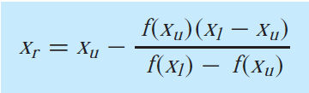
Code:
% False position method
clc; clear; close all;
% defining function
f = @(x)x^3+x-1;

% inputs
xl = 0;
xu = 1;
tol = 0.001; %corect up to 3 decimal
max_iter = 100;

if f(xl)*f(xu) > 0
error('No root exists in the given interval[xl,xu].');
end

xr = xl;
iter = 0;
ae = 100;%approximate error

fprintf('Iter\t xl\t\t\t xu\t\t xr\t\t ae(%%)\n');

while ae > tol && iter < max_iter
iter = iter + 1;
xr_old = xr;

% False Position Formula
xr = xu-(f(xu)*(xl - xu))/(f(xl)-f(xu));

if xr ~=0
ae=abs((xr-xr_old)/xr)*100;
end

fprintf('%d\t\t %.6f\t %.6f\t %.6f\t %.6f\n', iter, xl, xu, xr, ae);

% updating brackets
if f(xl)*f(xr)<0
xu=xr;
elseif f(xl)*f(xr)>0
xl=xr;
else
break;
end
end

fprintf('\nEstimated Root: %.4f\n', xr);

Output:
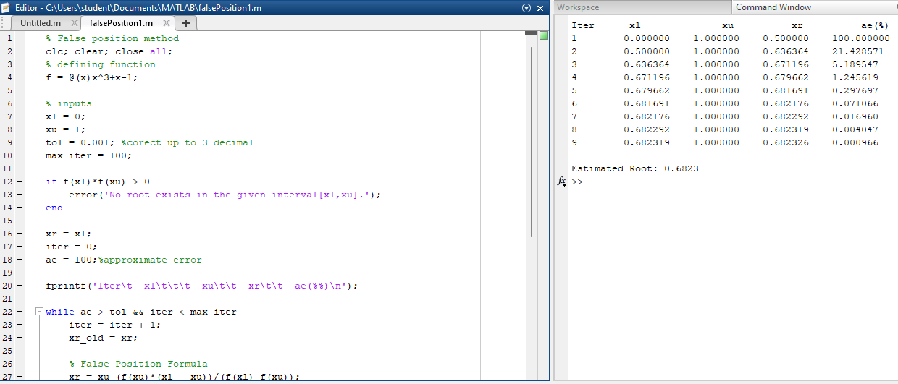

Part 2: Stopping Criteria
Stopping criteria tell the program when to stop to avoid unnecessary calculations or infinite loops:
- Absolute Relative Approximate Error ($a_{e}$):
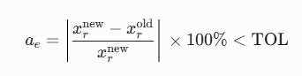
- Absolute Function Value Tolerance:
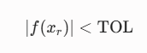
Checks if plugging the root estimate into $f\left(x\right)$ gives a result close to zero.

- Maximum Iteration Limit:
iter >= max_iter

Limits total loop count to prevent infinite execution if convergence fails.

Part 3: Improving the Method

One flaw with basic False Position is that curved graphs can cause one boundary point to get "stuck", slowing down the search.

Fix: If an endpoint doesn't move for two steps in a row, the algorithm cuts its function value in half (f(x_stagnant)/2). This tilts the next interpolating line across the root, unsticking the boundary and speeding up convergence.

Part 4: Comparison Task (Bisection vs. False Position)
Evaluating f(x) = 3x + sin(x) - e^x = 0 over 5 iterations in interval [0, 1]
Code:
clc; clear;
% define target equation and reference root
f = @(x) 3*x + sin(x) - exp(x);
exact_root = 0.360421703;
% initial brackets [0, 1]for both methods
xl_b = 0; xu_b = 1;%bisection value
xl_f = 0;
xu_f = 1;%false position value
% print table header
fprintf('Iter\tBisection x\tBisection f(x)\t\tFalse Pos x\tFalse Pos f(x)\n');
for i = 1:5
% ---bisection method
xr_b = (xl_b + xu_b) / 2;
fx_b = f(xr_b);
if f(xl_b)*fx_b < 0
xu_b = xr_b;
else
xl_b = xr_b;
end
% --- false position method
xr_f = xu_f - (f(xu_f) * (xl_f-xu_f)) / (f(xl_f) - f(xu_f));
fx_f=f(xr_f);
if f(xl_f)*fx_f < 0
xu_f =xr_f;
else
xl_f =xr_f;
end
% print results for current step
fprintf('%d\t%.6f\t%.6f\t\t%.6f\t%.6f\n',i,xr_b,fx_b, xr_f,fx_f);
end

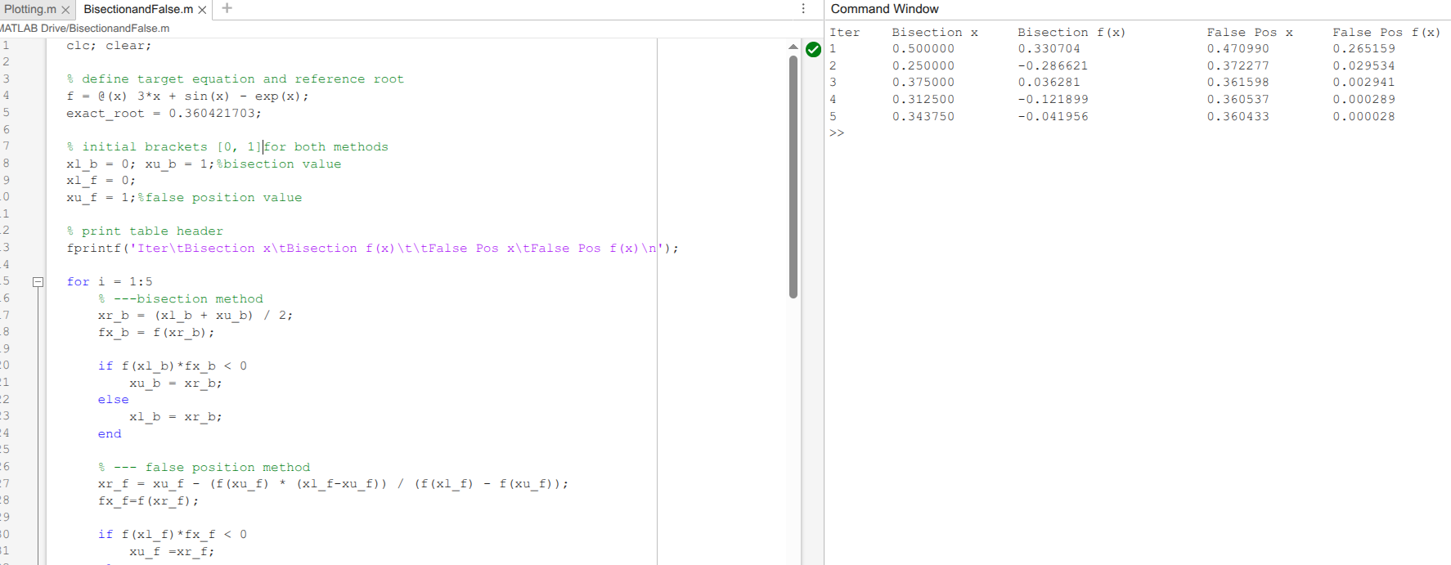
Task 2: Open & Fixed Point
Target Non-linear Equation: e^(x²) + 0.3 ln(x) = 2 sqrt(x)
1. MATLAB Plotting & Root Identification
Code:
clc; clear; close all;
% domain x>0 due to natural logarithm & square root
x = 0.01:0.01:1.5;
f = exp(x.^2) + 0.3*log(x)-2*sqrt(x);
figure;
plot(x, f,'b-', 'LineWidth', 1.5); hold on;
grid on;
yline(0,'r--', 'f(x) = 0');
xlabel('x'); ylabel('f(x)');
title('Plot of f(x) = e^{x^2} + 0.3 ln(x) - 2\sqrt{x}');
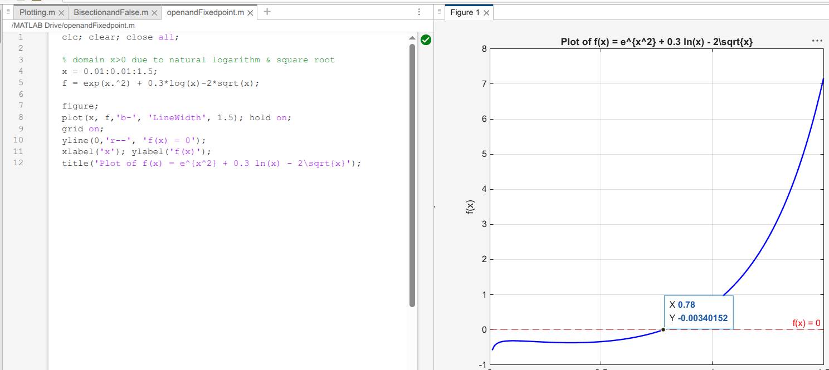
Observation: The graph crosses the line f(x) = 0 at x ~ 0.78, indicating one real root between 0 and 1.

2. Rearrangement & Convergence Test
To set up fixed-point iteration x_(i+1) = g(x_i) from e^(x²) + 0.3 ln(x) = 2√(x):
- Rearrangement 1 (isolating ln(x)):
g_1(x) = exp( [ 2√(x) - e^(x²) ] / 0.3 )
- Rearrangement 2 (isolating √(x)):
g_2(x) = [ ( e^(x²) + 0.3 ln(x) ) / 2 ]²

Convergence Check (|g'(x)| < 1):
Evaluating derivatives near x ≈ 0.78:
- |g_1'(0.78)| ≈ 4.51 > 1 --> Diverges
- |g_2'(0.78)| < 1 --> Converges
So, g_2(x) is the correct choice.

3. Validity of Initial Guess x_0 = -1
Invalid.
Both ln(x) and √(x) require x > 0 in the real domain. Plugging in x_0 = -1 gives complex numbers, making it unusable as a real starting point.

4. Two Steps of Fixed-Point Iteration
Using g(x) = [ ( e^(x²) + 0.3 ln(x) ) / 2 ]² and starting guess x_0 = 0.5:

- Step 1 (i = 1):
x_1 = g(0.5) = [ ( e^(0.25) + 0.3 ln(0.5) ) / 2 ]² = [ ( 1.284 - 0.208 ) / 2 ]² = 0.2895
e_a = | ( 0.2895 - 0.5 ) / 0.2895 | * 100% = 72.7%
- Step 2 (i = 2):
x_2 = g(0.2895) = [ ( e^(0.2895²) + 0.3 ln(0.2895) ) / 2 ]² = [ ( 1.087 - 0.372 ) / 2 ]² = 0.1280
e_a = | ( 0.1280 - 0.2895 ) / 0.1280 | * 100% = 126.2%

Iterations continue until error drops below 10^-7 as it approaches x ≈ 0.78.

Task 3: Newton-Raphson Method & Pitfall Evaluation

Code:
clc; clear; close all;
%function with slope variation
f = @(x) x.^3 -2*x + 2;
df = @(x) 3*x.^2 -2;
% initial guess near a slope transition point
x0 = 0;
max_iter= 10;
x= x0;
fprintf('Iteration history for NewtonRaphson pitfall:\n');
for i=1:max_iter
%safety check for zero derivative
if df(x) == 0
error('derivative is zero. NewtonRaphson method fails.');
end
x_next=x- f(x)/df(x);
fprintf('iter %d:x= %.6f\n',i, x_next);
x =x_next;
end

Result:
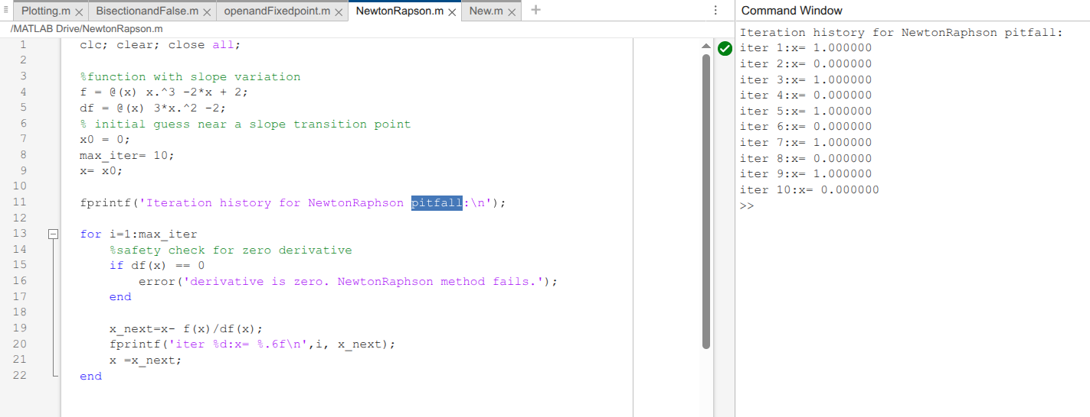
c

